3.OA.8 Select 2 choices in each row and have your teacher sign off before moving to the next step!

Teacher Checkpoint | I learn better by listening. | I learn better by seeing. | I learn better by writing/creating.
_________  Small Group  ________  Conference  ______  Checkpoint Score | Listen to the video on problem solving. Complete a graphic organizer to show what you learned about solving two step problems with a model! | Play the Thinking Blocks multiplication app. Record your problems and write a reflection on your work! (Did you think it was easy, difficult, what questions do you have?) | Ben has two cats. Each cat eats one can of wet cat food per day. Cat food is sold with 24 cans in a case. Ben wants to buy enough cat food for two weeks. If he buys one case is this enough cat food? Represent your thinking and explain your answer!
_________  Small Group  ________  Conference  _________  Checkpoint Score | Listen to the video on problem solving. Complete a graphic organizer to show what you learned about estimating solutions to problems! | Review the following model for the problem. Does it make sense for this problem? Why or why not? How does the model help you solve the problem? (Write 3-5 sentences to answer)  Write your own problem and create your own model to help visualize your problem. 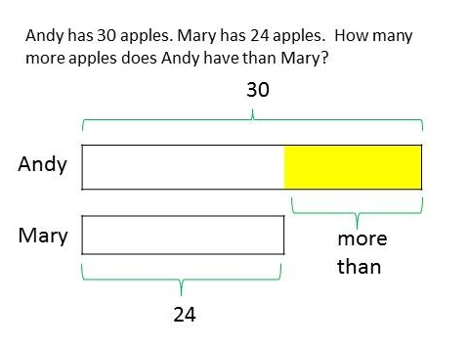 | There are 61 third-grade students in Amy’s school. 19 of the them are in the library. How many are left in their classrooms? If each classroom holds about 20 students, how many classrooms are likely being used? Create a poster to show your solution!
_________  Small Group  ________  Conference  ________  Checkpoint  Score | Practice solving the following problems. Write down your score and write a reflection on your work! (Did you think it was easy, difficult, what questions do you have?) | Draw a comic strip for the following problem (Think about what happened first, next, and what happens in order to solve the problem!.):  Josie needs 85 cupcakes for a birthday party. She has 31 strawberry cupcakes and 16 chocolate cupcakes. How many more cupcakes does she need?  Use your comic strip to solve! | Mrs. Moore’s third grade class wants to go on a field trip to the science museum.  The cost of the trip is $245. The class can earn money by running the school store for 6 weeks. The students can earn $15 each week if they run the store. How much more money does the third grade class still need to earn to pay for their trip?  Create a way to share your solution!.

