Third Grade Geometry Assessment
Teacher Guide

This assessment assesses students’ ability to:
- Identify the attributes of triangles, quadrilaterals, pentagons, hexagons, octagons, and hexagons.
- Describe, define, and sort quadrilaterals.
- Measure and record the perimeter of polygons.
- Find the perimeter of an irregular polygon.
- Compare shapes based on perimeters.

Common Core Standards:
This assessment addresses each of the following Common Core Standards (standards in red are major work standards for your grade level):
Standard | Questions
3.MD.8 | 4, 5, 6, 10, 11, 12, 14
3.G.1 | 1, 2, 3, 7, 8, 9, 13

Assessment Administration:
This assessment is calculator active. Students may use a calculator for all questions on this assessment. Students are required to receive all assessment accommodations as described in their Individualized Education Plans.

Data Driven Instruction:
This assessment is one data point and should be used with data gathered from multiple sources to make an informed decision about student misconceptions and mastery.

3rd Grade CMS Geometry Assessment – Scoring Guide

Question | Standard | Answer
1 | 3.G.1 | C
2 | 3.G.1 | A
3 | 3.G.1 | B
4 | 3.MD.8 | D
5 | 3.MD.8 | C
6 | 3.MD.8 | A
7 | 3.G.1 | C
8 | 3.G.1 | B
9 | 3.G.1 | D
10 | 3.MD.8 | B
11 | 3.MD.8 | A
12 | 3.MD.8 | B
13 | 3.G.1 | Rubric
14 | 3.MD.8 | Rubric

Rubric Scoring Guide:

Question 13 (4 points):
Student receives 1 point for each of the following bullets:
- Student identifies the first shape as a rhombus
- Student identifies the second shape as a rectangle
- Student gives 2 attributes that the shapes have in common (ie 4 sides, opposite sides never meet)
- Student gives 2 attributes that the shapes do not have in common (ie rectangle has square corners, rhombus has equal sides)

*Consider giving half credit on each of these items. For example if student uses a less specific name such “quadrilateral” or “parallelogram” for the rhombus, give half credit because the shape does fit in that category, it’s just not the most specific name. Also for the last two questions, students may receive half credit if they only give 1 attribute instead of 2.

Question 14 (3 points):
Student receives 1 point for each correct equation.

Possible Equations:
1 + 1 + 7 + 7 = 16
2 + 2 + 6 + 6 = 16
3 + 3 + 5 + 5 = 16
4 + 4 + 4 + 4 = 16

*Note that addends may appear in different order (ie 1 + 7 + 1 + 7 = 16)

Student Name: ________________________ Date: _________

3rd Grade CMS Geometry Assessment
Directions: Solve each problem and show your work.
You may use a calculator for this test.

1. Anna drew a pentagon. Her pentagon had some square corners. Which shape might be the one Anna drew?

A B C D

2. Ms. King asked her students to draw a quadrilateral with exactly two pairs of opposite sides that will never meet. Which shape might her students draw?

A B C D

3. Which shape is a rhombus?

A B C D

4. Emily has a swimming pool at her house. She wants to put a fence around the pool for safety. The length of the pool is 24 feet. The width of the pool is 15 feet. How much fencing does Emily need to buy to go all the way around the rectangular pool?
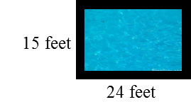

A 39 feet B 49 feet

C 68 feet D 78 feet

5. What is the perimeter of this figure?
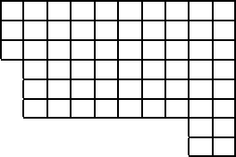

A 30 units
B 32 units
C 36 units
D 61 units
6. The perimeter of this triangle is 109 yards. What is the length of the missing side?
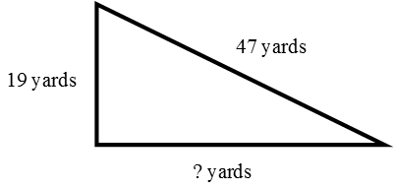

A 43 yards
B 53 yards
C 56 yards
D 66 yards

7. Which of the following sets contains only quadrilaterals?
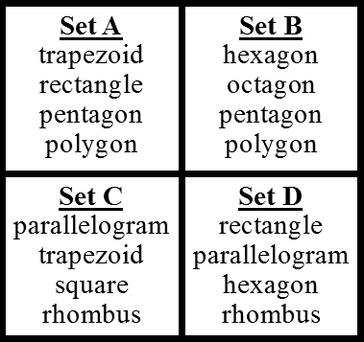

A Set A
B Set B
C Set C
D Set D

8. Which of the following has sides that are not equal?

A B C D
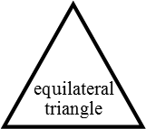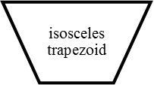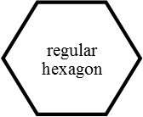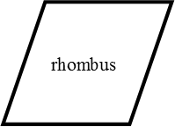

9. Logan drew a hexagon with unequal sides. Which of the following could be the hexagon that he drew?
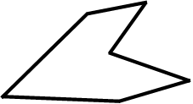
A B C D

10. Raul drew a regular hexagon. The perimeter of his hexagon was 30 inches. What is the length of one side on Raul’s hexagon?

A 4 inches B 5 inches C 6 inches D 7 inches
11. Which figure has the same perimeter as this figure?
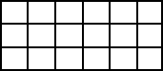

A B C D
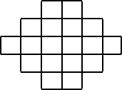
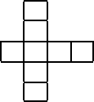
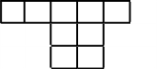

12. Mrs. Rosales drew this rectangle. The perimeter of the rectangle is 26 centimeters. What is the length of the rectangle?
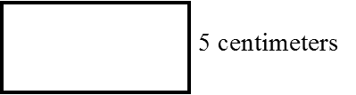

A 6 centimeters B 8 centimeters
C 10 centimeters D 16 centimeters

13. Look at the two shapes below. Name the shapes below with their most specific name and answer the questions below.

Name: ____________________ Name: ______________________
What are two attributes that the shapes have in common?
____________________________________________________________________________

What are two attributes that are different on the two shapes?
____________________________________________________________________________

14. Draw three different rectangles below that have a perimeter of 16. Record the equations to represent the perimeter below.

Equation 1: ________________________________________
Equation 2: ________________________________________
Equation 3: ________________________________________

