Third Grade Quarter 1 Assessment
Teacher Guide

This assessment assesses students’ ability to:
- Use at least one strategy to efficiently solve addition and subtraction word problems.
- Find combinations of 2-digit numbers that equal 100.
- Write equations to represent combinations of 100.
- Add and subtract multiples of 10.
- Estimate sums of 2-digit numbers up to 100.
- Keep track of all parts of a word problem.
- Represent problems using a letter or symbol to represent the unknown.
- Identify the attributes of triangles.
- Identify the attributes of quadrilaterals.
- Describe, define, and sort quadrilaterals.
- Measure and record the perimeter of polygons.
- Find the perimeter of an irregular polygon.
- Compare and order shapes based on perimeters.
Common Core Standards:
This assessment addresses each of the following Common Core Standards (standards in red are major work standards for your grade level):
Standard | Questions
3.NBT.2 | 1, 2, 3, 7, 15, 16
3.OA.8 | 4, 5, 6, 14
3.MD.8 | 8, 11, 13, 18
3.G.1 | 9, 10, 12, 17

Assessment Administration:
This assessment is separated into calculator inactive (questions 1-9) and calculator active (questions 10-18) sections. Students should not use a calculator for the calculator inactive questions. Once students have complete the calculator inactive section, please clip or collect the calculator inactive section, and provide the student with a calculator to complete the calculator active section of this assessment. If students are entering answers on a bubble sheet, please make sure students have completed the calculator inactive section of the bubble sheet before collecting this portion of the assessment.

Data Driven Instruction:
This assessment is one data point and should be used with data gathered from multiple sources to make an informed decision about student misconceptions and mastery.

3rd Grade Quarter 1 Assessment – Scoring Guide

Question | Standard | Answer
1 | 3.NBT.2 | D
2 | 3.NBT.2 | A
3 | 3.NBT.2 | D
4 | 3.OA.8 | C
5 | 3.OA.8 | A
6 | 3.OA.8 | B
7 | 3.NBT.2 | A
8 | 3.MD.8 | D
9 | 3.G.1 | D
10 | 3.G.1 | B
11 | 3.MD.8 | B
12 | 3.G.1 | A
13 | 3.MD.8 | C
14 | 3.OA.8 | C
15 | 3.NBT.2 | B
16 | 3.NBT.2 | C
17 | 3.G.1 | B
18 | 3.MD.8 | D

Student Name: ________________________ Date: _________

3rd Grade Quarter 1 Assessment

Directions:
Calculator Inactive: #1-9
You may NOT use a calculator for this section of the test.
Calculator Active: #10-18
You may use a calculator for this section of the test, but you should not go back to the previous section of the test.

Solve each problem and show your work.
_________________________________________________________________________

1. Jennifer read 78 pages last week. She read 45 pages less than her friend Shannon. How many pages did Shannon read last week?

A 33 B 43

C 113 D 123

2. Erik has 47 baseball cards. He is putting them in a book that holds 113 baseball cards. How many more baseball cards does he need to fill his book?

A 66 B 76

C 134 D 160

3. Aditya went to Sticker Station where stickers are sold in sheets of one hundred, strips of ten, and single stickers.

- Aditya bought 3 sheets of flower stickers.
- Aditya bought 14 strips of flower stickers.
- Aditya bought 46 single flower stickers.

How many stickers did Aditya buy in all at Sticker Station?

A 350 B 360

C 446 D 486

4. What is the value of G in this equation?

85 = G – 16

A 69 B 91
C 101 D 111

5. Mr. Chen’s class had a box with many extra pencils at the beginning of the year.

- They used 27 of the extra pencils in August.
- They used 67 of the extra pencils in September.
- Now there are 16 pencils left in the box.

How many pencils did the class have at the beginning of the year?

A 110 B 94

C 88 D 78

6. Ms. Palermo has a goal to read 120 pages this week.

- She read 39 pages on Monday.
- She read 18 pages on Tuesday.

How many more pages does she have left to make her goal?

A 57 B 63

C 73 D 77

7. Brianna built a tower that was 74 blocks tall. Her brother put more blocks on until the tower was 132 blocks tall. How many blocks did Brianna’s brother add to the tower?
A 58 B 62
C 106 D 206

8. Nancy’s garden has 4 sides.

- The distance around the garden is 149 feet.
- Three sides of her garden measure 42 feet, 48 feet, and 23 feet.

How long is the fourth side of the garden?

A 262 B 113
C 103 D 36

9. Dimitri drew the following shapes on his page:
What title could he use to describe all of the shapes?
A trapezoids B rectangles
C parallelograms D quadrilaterals
Student Name: ____________________
Calculator Active: You may use a calculator on this part of the test.

10. Susan was told to draw a quadrilateral with exactly two pairs of opposite sides that will never meet or cross. Which shape could Susan draw?
A B

C D
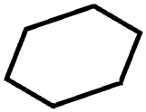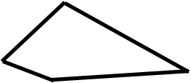

11. Aiden’s backyard has a perimeter of 54 yards. One side is 20 yards long.

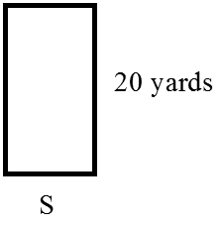
How long is side “s”?

A 4 yards B 7 yards

C 14 yards D 34 yards

12. Andrew sorted the following shapes using a rule. What name could Andrew give to all the shapes that fit his rule?

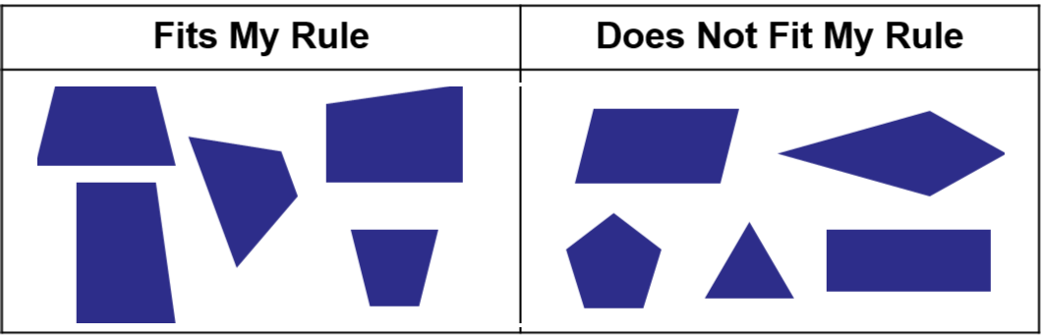

A trapezoids B parallelograms

C pentagons D triangles

13. The polygon below is made of two hexagons. The length of each side of each hexagon is 5 cm.

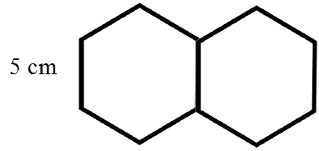

What is the perimeter of the polygon?

A 30 cm B 40 cm

C 50 cm D 60 cm

14. What is the value of the b in this equation?

40 + b = 47 + 39

A 126 B 86

C 46 D 7

15. Louis put a box of snap cubes into groups of ten. He made 13 groups of ten and had 5 snap cubes leftover. Louis decided to put his snap cubes in groups of one hundred instead. How many groups of one hundred can he make? How many will be leftover?

A 1 group of 100, 5 leftover
B 1 group of 100, 35 leftover
C 4 groups of 100, 5 leftover
D 4 groups of 100, 35 leftover

16. Four office stores compared the number of pencils they had in stock.
Store | Boxes of 100 Pencils | Packs of 10 Pencils | Single Pencils
Office Mania | 0 | 14 | 9
Pencils Plus | 1 | 6 | 4
Discount Office Supply | 1 | 3 | 7
School & Office Store | 0 | 17 | 2

Which store had the least number of pencils?

A Office Mania B Pencils Plus
C Discount Office Supply D School & Office Store

17. Look at the two figures below. Which of the following describes an attribute that the two figures have in common?

A Both figures have one pair of opposite sides that will never meet or cross.
B Both figures have at least one square corner.
C Both figures have equal sides.
D Both figures have exactly three sides.

18. Which of the following shows two figures with the same perimeter?

A B
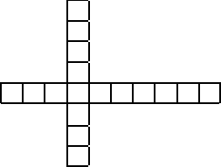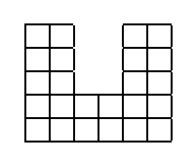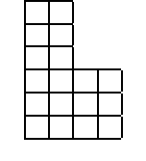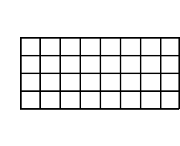

C D
