Third Grade Unit 3 Assessment
Teacher Guide

This assessment assesses students’ ability to:
- Add and subtract within 1,000.
- Solve multi-step addition and subtraction problems.
- Use equations to represent mathematical situations.
- Estimate sums of 2-digit and 3-digit numbers up to 1,000.
- Represent problems using a letter or symbol to represent the unknown.
- Use patterns in addition and subtraction to solve problems.

Common Core Standards:
This assessment addresses each of the following Common Core Standards (standards in red are major work standards for your grade level):
Standard | Questions
3.NBT.1 | 18
3.NBT.2 | 1, 2, 6, 11, 12
3.OA.8 | 3, 4, 7, 9, 13, 17
3.OA.9 | 5, 8, 10, 14, 15, 16

Assessment Administration:
This assessment is separated into calculator inactive (questions 1-11) and calculator active (questions 12-18) sections. Students should not use a calculator for the calculator inactive questions. Once students have completed the calculator inactive section, please clip or collect the calculator inactive section, and provide the student with a calculator to complete the calculator active section of this assessment. If students are entering answers on a bubble sheet, please make sure students have completed the calculator inactive section of the Teachers should use the rubric to score these questions.

Data Driven Instruction:
This assessment is one data point and should be used with data gathered from multiple sources to make an informed decision about student misconceptions and mastery.

3rd Grade Unit 3 Assessment – Scoring Guide

Question | Standard | Answer
1 | 3.NBT.2 | D
2 | 3.NBT.2 | A
3 | 3.OA.8 | D
4 | 3.OA.8 | B
5 | 3.OA.9 | B
6 | 3.NBT.2 | A
7 | 3.OA.8 | A
8 | 3.OA.9 | D
9 | 3.OA.8 | A
10 | 3.OA.9 | Rubric
11 | 3.NBT.2 | Rubric
12 | 3.NBT.2 | A
13 | 3.OA.8 | D
14 | 3.OA.9 | D
15 | 3.OA.9 | B
16 | 3.OA.9 | C
17 | 3.OA.8 | D
18 | 3.NBT.1 | C

Question 10 (4 points):
Student receives 1 point for each of the following bullets:
- Student circles the numbers 57, 72, 107, and 192, but does not circle any other numbers.
- Student identifies an important feature about the ones digit or tens digit in Aron’s pattern. (Examples: The ones digit repeats 2, 7, 2, 7. The tens digit repeats 2 times and then changes to the next ten.)
- Students should record 3 numbers over 200 with a 2 or a 7 in the ones place.
- Student identifies the rule as “add/plus 5” to find the next number.
Question 11 (3 points):
Student receives 1 point for each of the following bullets:
- Student shows one strategy to solve the problem (adding up, subtracting back, breaking apart by place value, open number line, base ten blocks drawings, etc).
- Student shows a different strategy to solve the problem (see strategies/tools above).
- Student states that Henry needs to ride 63 more miles to reach his goal.

Student Name: ________________________ Date: _________

3rd Grade Unit 3 Assessment

Directions:
Calculator Inactive: #1-11
You may NOT use a calculator for this section of the test.
Calculator Active: #12-18
You may use a calculator for this section of the test, but you should not go back to the previous section of the test.

Solve each problem and show your work.
_________________________________________________________________________

1. Addison read 773 pages over summer break. She read 192 pages less than her friend Joseph. How many pages did Joseph read over summer break?

A 581 B 621

C 865 D 965

2. Raquel has 274 beads. She is working on a craft that uses 503 beads. How many more beads does she need to finish the craft?

A 229 B 279

C 329 D 777

3. Juan read 32 pages of his book on Monday. He read 46 pages on Tuesday and 38 pages on Wednesday. About how many pages did Juan read? Round to the nearest ten.

A 70 B 80

C 110 D 120

4. Caroline’s family is taking a trip to Daytona Beach, Florida. The trip from Charlotte to Daytona Beach is 488 miles. Caroline’s family has already traveled 129 miles, about how many more miles do they need to travel?

A 300 B 400
C 500 D 600

5. Selena started with the number 18 and used a rule to create the pattern below. Which rule could Selena have used?

18, 24, 30, 36, 42

A add 5 B add 6

C add 7 D add 18

6. The manager at a store had a customer request a large number of pencils. The store sold pencils in boxes of 100, packs of 10, and as single pencils.

- The store had 6 boxes of pencils.
- The store had 23 packs of pencils.
- The store had 65 single pencils.

How many pencils did the manager have to sell to the customer?

A 895 B 868

C 688 D 94

7. Three classes collected cans for a food drive. The table below shows how many cans each class collected.

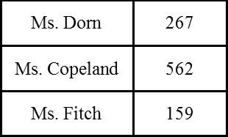

How many more cans did Ms. Copeland’s class collect than Ms. Dorn’s and Ms. Fitch’s classes combined?

A 136 B 166
C 670 D 988

8. Miguel needs to figure out what number goes in the blank. What is one way that Miguel can figure out what number goes in the blank?

26, 32, 38, 44, ___, 56, 62

A 56 - 44 B 56 + 6
C 44 - 6 D 56 - 6

9. Thomas has a goal to read 500 pages in October.

- He read 128 pages in the first week.
- He read 215 pages in the second week.

How many more pages does he have left to make his goal?

A 157 B 257
C 343 D 843

Open Response Questions:
Questions 10 and 11 are open response questions. You will need to use pictures, numbers, or words to answer these questions.

10. Aron is writing the pattern shown below.

2, 7, 12, 17, 22, 27, 32, 37....

Some of the numbers below are numbers that Aron would write if he continued his pattern to 200. Circle the numbers that Aron would write.

40 57 72 78 107 115 192

What statement can you make about the ones digits or the tens digits in all of the numbers in Aron’s pattern?

What are 3 more numbers that Aron would write if he extended the pattern over 200?

What rule does Aron’s pattern follow?

11. Henry is practicing for a long bike race. He has ridden his bike for 137 miles in the first three weeks of November. His goal is to ride a total of 200 miles in November. Show two strategies to find how many more miles Henry needs to ride to make his goal.

Strategy 1: | Strategy 2:

Student Name: ____________________
Calculator Active: You may use a calculator on this part of the test.

12. Sunshine Elementary School has 10 classes.

- There are 210 students in third grade.
- 146 of the third graders are boys.

How many girls are in third grade?

A 64 B 76

C 136 D 356

13. What is the value of T in this equation?

74 + 28 = T - 18

A 84 B 96

C 102 D 120

14. Jayce wrote the pattern 32, 29, 26, 23, 20. Which pattern appears to use the same rule as Jayce's pattern?

A 40, 43, 46, 49, 52 B 54, 50, 46, 42, 38

C 42, 40, 38, 36, 34 D 50, 47, 44, 41, 38

15. Anton is building a tower with blocks. He records the number of blocks he has used after completing each level.

- The first level had 18 blocks.
- He adds 6 blocks for each new level.

Level 1 | Level 2 | Level 3 | Level 4 | Level 5 | Level 6
18 blocks | 24 blocks | 30 blocks | 36 blocks | 42 blocks | 48 blocks

Which of the following is true about the number of blocks that Anton might have if he continues to build higher levels with 6 more blocks?

A The digit in the tens place will never be greater than 5.
B The number of blocks will always be even.
C It is possible for 5 to be the digit in the ones place.
D The digit in the tens place will never repeat.

16. Use the following chart to determine which of the following statements is true.

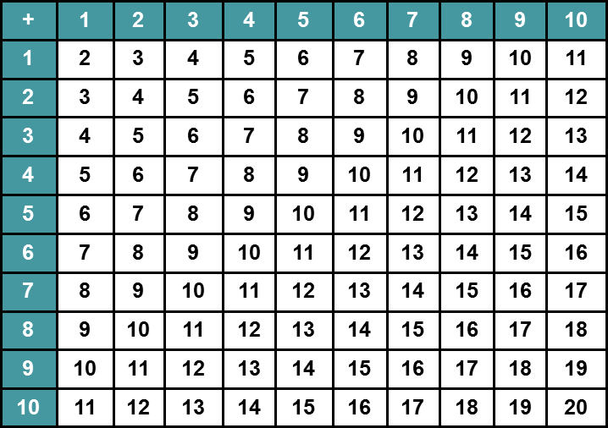

A Each sum only appears once on the chart.
B The sum of two odd numbers is always odd.
C The difference between the first and last unshaded number in each column is always the same.
D The row that begins with 4 has different sums than the column that begins with 4.

17. What is the value of b in this equation?

154 = b - 61
A 93
B 115
C 195
D 215

18. The aquarium workers stated that the octopus weighed 110 pounds rounded to the nearest ten. Which of the following could be the actual weight of the octopus?

A 100 pounds B 104 pounds
C 106 pounds D 115 pounds

