Lemonade Stand
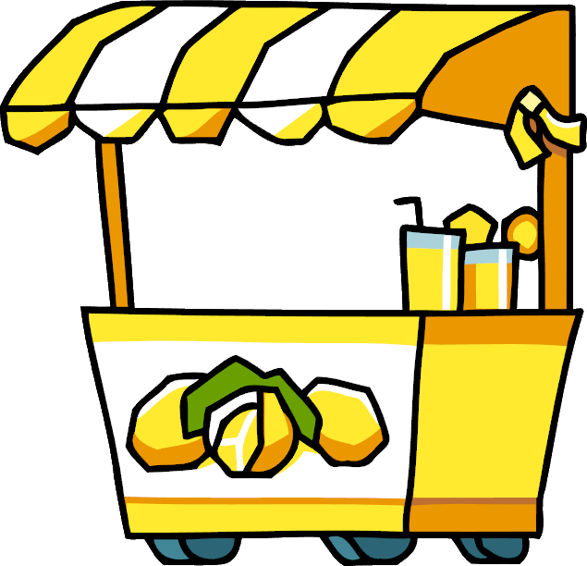
3rd Grade

Subject | Math
Materials | iPad or Chromebook; Google Classroom; Lemonade, Cups, Measuring Tools
Summary | Your students are the proud owners of a new Lemonade Stand. Students will create a business plan of what they will need and costs, create recipes, make their recipes, survey friends and create a picture graph based on the results, and then they will have a sales day where students are given “money” to buy lemonade from each other… who will sell the most!?  **Other lessons may be needed to provide background knowledge**
Standards | 3.MD.A.2 Measure and estimate liquid volumes and masses of objects using standard units of grams (g), kilograms (kg), and liters (l).1 Add, subtract, multiply, or divide to solve one-step word problems involving masses or volumes that are given in the same units, e.g., by using drawings (such as a beaker with a measurement scale) to represent the problem.  3.MD.B.3 Draw a scaled picture graph and a scaled bar graph to represent a data set with several categories. Solve one- and two-step "how many more" and "how many less" problems using information presented in scaled bar graphs.  3.NF.A.1 Understand a fraction 1/b as the quantity formed by 1 part when a whole is partitioned into b equal parts; understand a fraction a/b as the quantity formed by a parts of size 1/b.  3.NF.A.3 Explain equivalence of fractions in special cases, and compare fractions by reasoning about their size.  3.NBT.A.2 Fluently add and subtract within 1000 using strategies and algorithms based on place value, properties of operations, and/or the relationship between addition and subtraction.  3.NBT.A.3 Multiply one-digit whole numbers by multiples of 10 in the range 10-90 (e.g., 9 × 80, 5 × 60) using strategies based on place value and properties of operations.  3.OA.C.7 Fluently multiply and divide within 100, using strategies such as the relationship between multiplication and division (e.g., knowing that 8 × 5 = 40, one knows 40 ÷ 5 = 8) or properties of operations.  SL.3.1 Engage effectively in a range of collaborative discussions (one-on-one, in groups, and teacher-led) with diverse partners on grade 3 topics and texts, building on others' ideas and expressing their own clearly.  SL.3.4 Report on a topic or text, tell a story, or recount an experience with appropriate facts and relevant, descriptive details, speaking clearly at an understandable pace.

Congratulations! You are the proud owner of a new Lemonade Stand! Now is your chance to prove yourself as an entrepreneur and business owner. You have been gifted $100 from a family member who greatly believes in your ability to run a successful business. Your steps include:

- Make a goal for yourself as an entrepreneur.
- Create a business plan (What will you need? How much will it cost? What will you charge?)
- Create a few recipes to find the tastiest!
- Have a few friends taste your recipes and vote on their favorite.
- Create a picture graph of their results.
- Decide what you will charge and advertise!
- It’s sales day! Who will make the most money?
- Reflect on your business (What worked? What didn’t? What should be done differently next time?)

Good luck!

My entrepreneurial goals: ___________________________

______________________________________________

______________________________________________

______________________________________________

Create a Business Plan
Use the grocery list below to think of items you KNOW you will need! How many do you think you need of each? How much will it cost? See the example for how to complete the list. Keep in mind you only have $100!

After speaking with your teacher and/or classmates, what are some more items you realize you need to buy? Add those to your chart in another color. Make sure you update your total!!

What are some items you KNOW you will need? | How much do those items cost? | How many will you buy? | What is the total cost?
Cups | $5 for 24 cups | 4 packs (because I think I will sell a lot of lemonade!) | $5 x 4 packs =$20

TOTAL SPENT: ______________________
Grocery Store

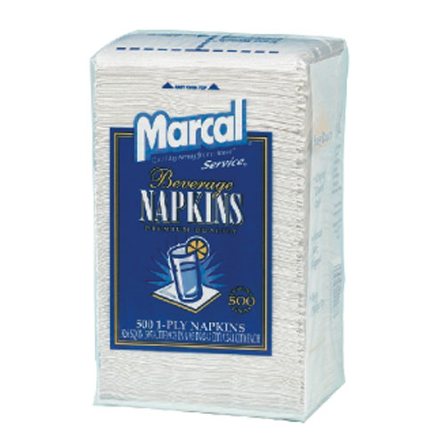  Napkins $5 for 100 napkins | 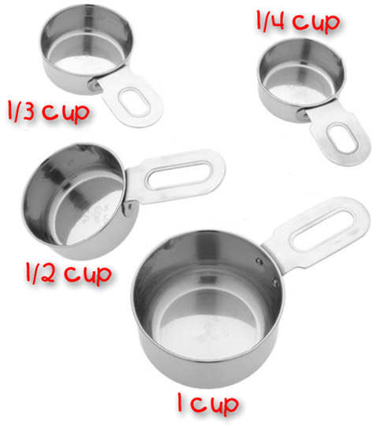Measuring cups $10 | 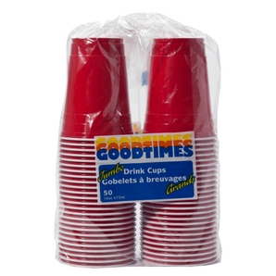  Plastic Cups $5.00 for 24 cups | 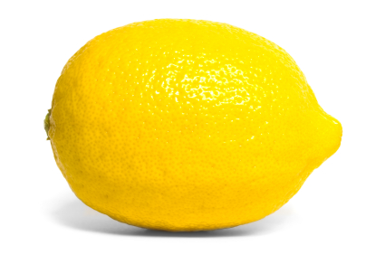  Lemon $0.50
Bandaids $5 | Paper Towels $6 | 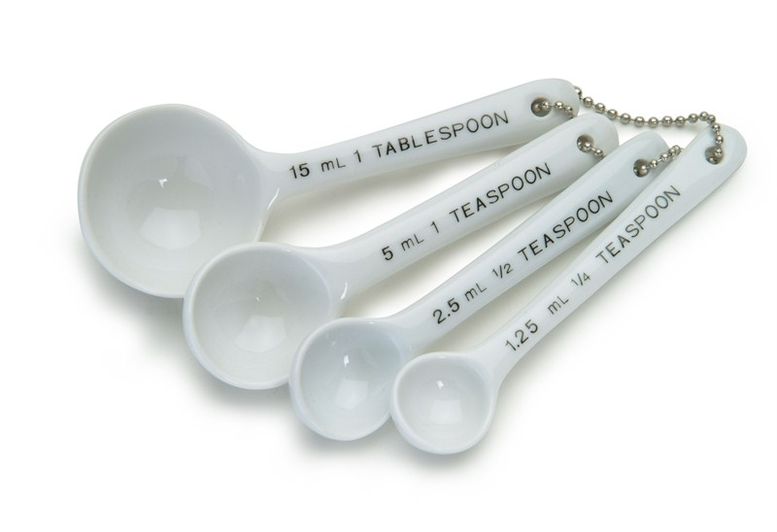Measuring spoons $10 | 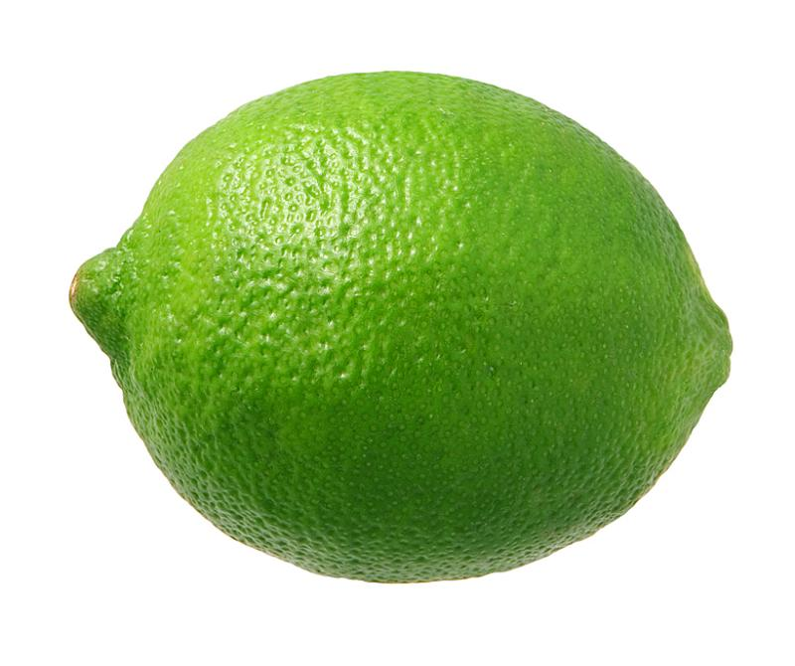  Lime $0.40
Plastic Wrap $3 | Kleenex $5 | 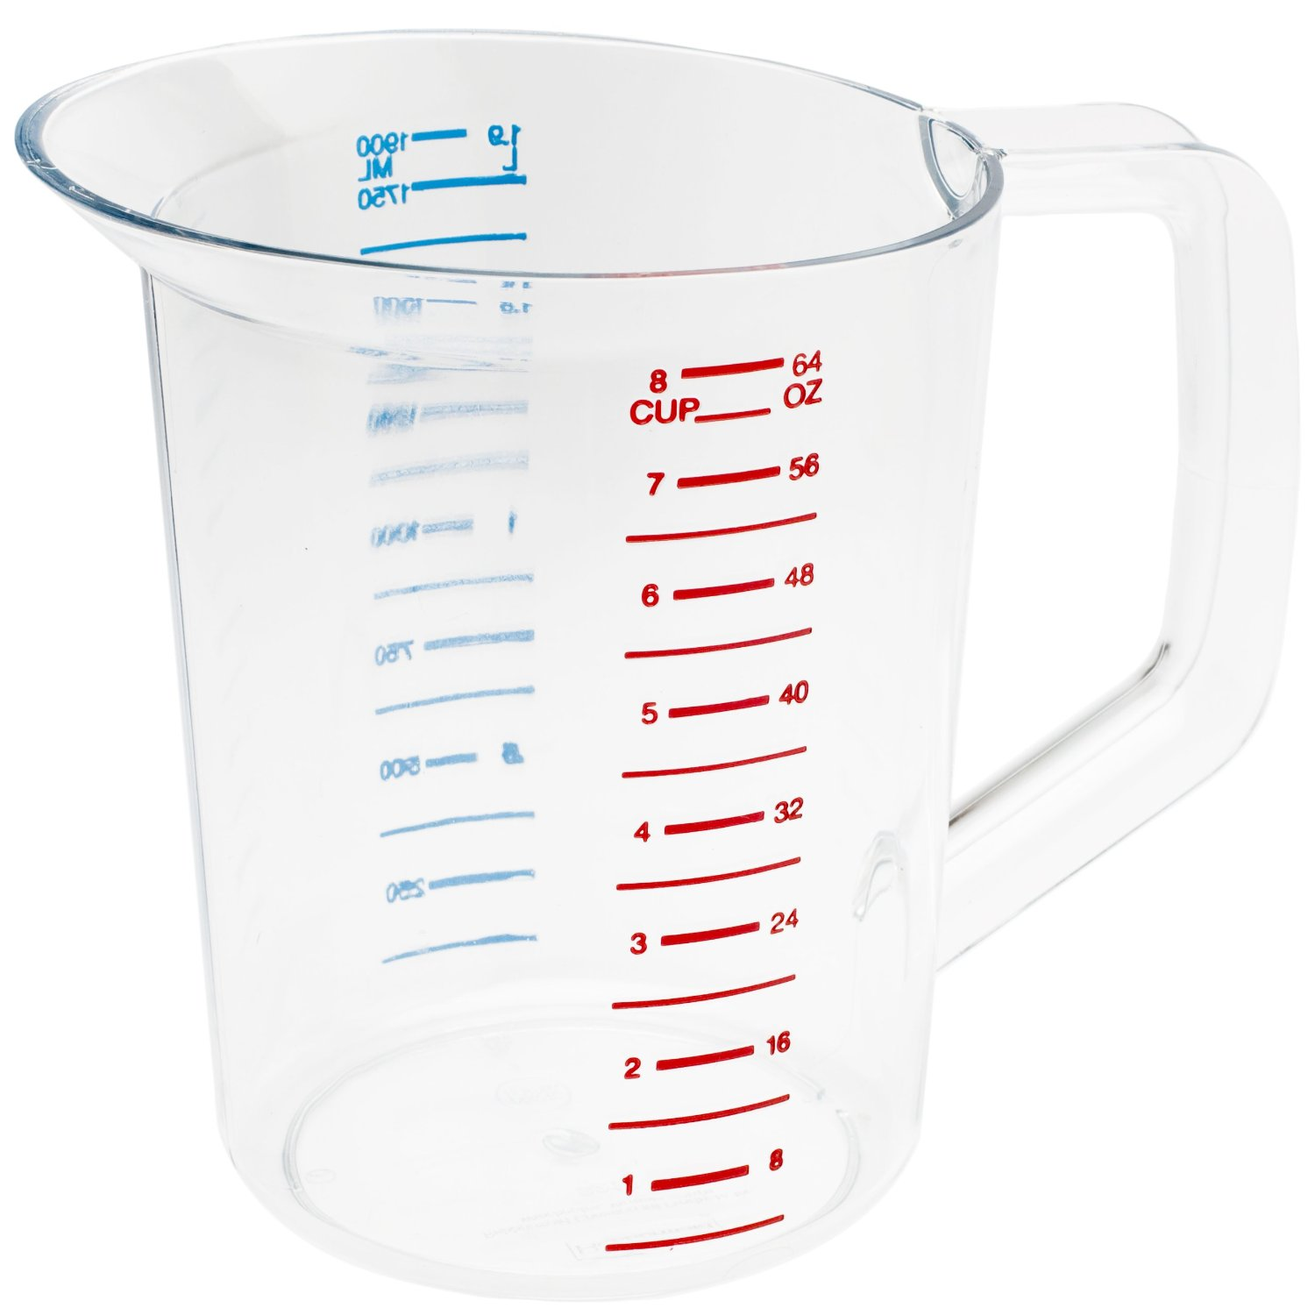  Plastic Pitcher $10 | 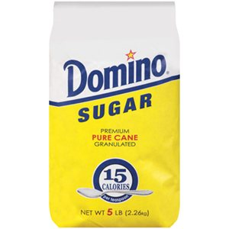  Sugar $4
Dishwashing Soap $5 | Hand Soap $5 | Wooden Spoon $8 | 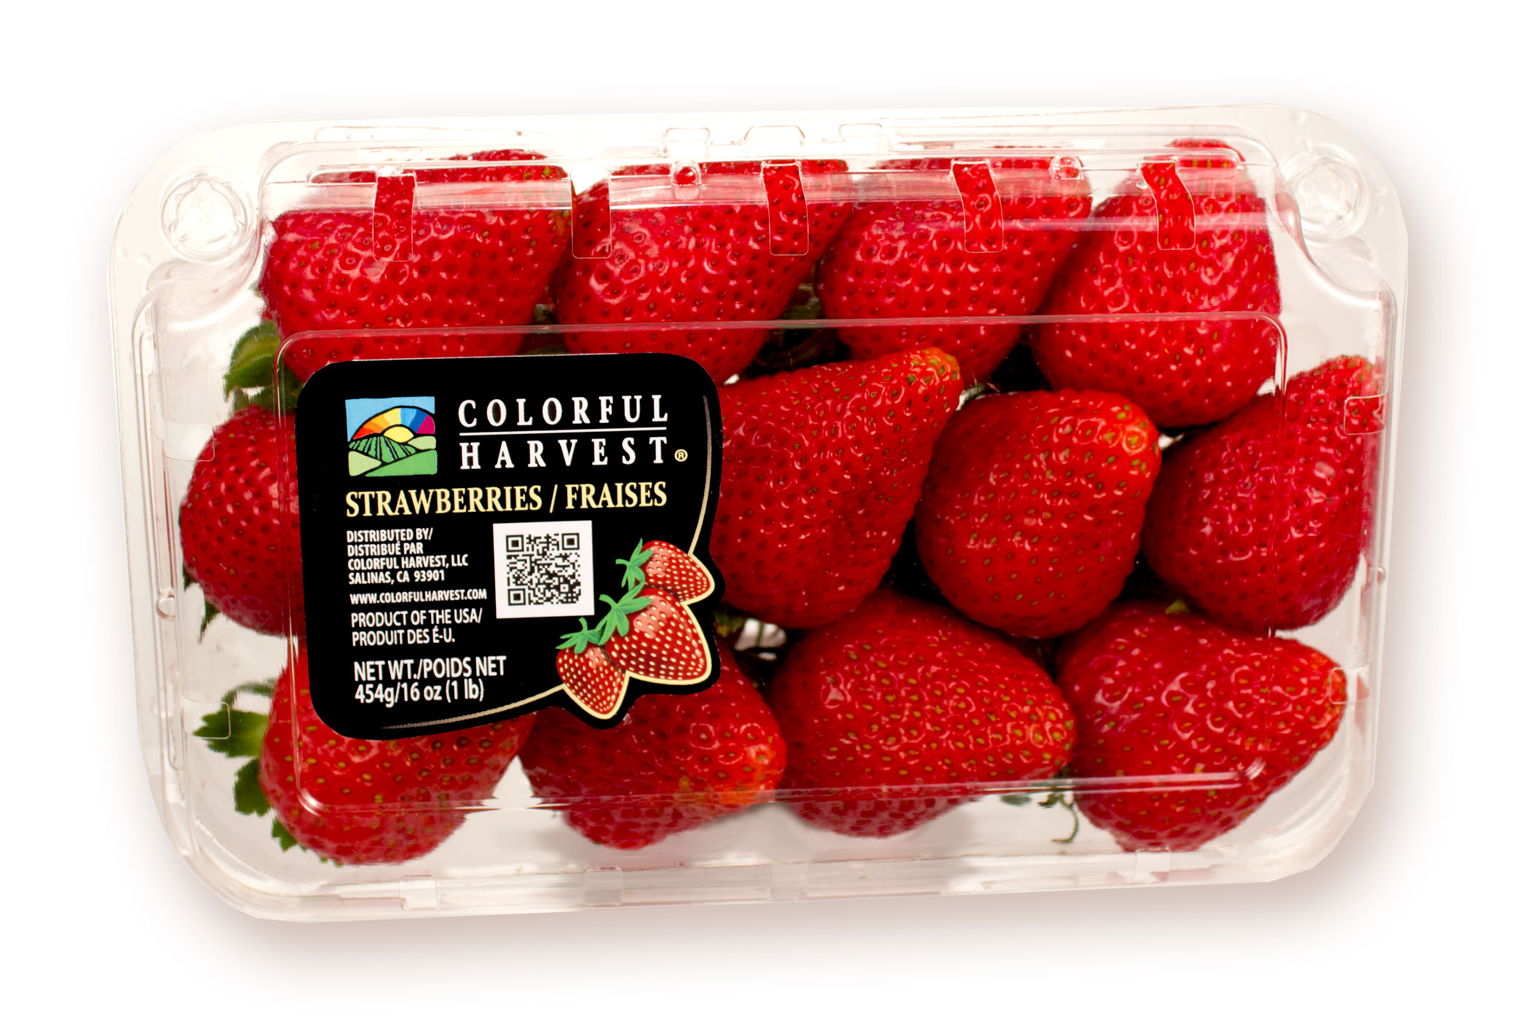  Strawberries $3

Create a few recipes to find the tastiest!

Use the measuring spoons to create 3 different recipes of lemonade you want to try and sell. Make sure you write the recipe down as you make it!

Example:
Recipe 1
Recipe | Instruction
- ¼ of a lemon  - ½ cup of water  - 1 tsp sugar | - Toss in glass  - Mix with wooden spoon  - Enjoy!

Recipe 1 |  | Recipe 2 |  | Recipe 3
Recipe | Instruction | Recipe | Instructions | Recipe | Instructions

Have a few friends taste your recipes and vote on their favorite!

Make your 3 recipes in 3 different pitchers.

Have your friends taste all 3 and vote on their favorite.

Tally their votes in the chart below.

Recipe 1 | Recipe 2 | Recipe 3

Which recipe was the winner!?
On a separate piece of paper, Create a picture graph of their results! Be sure to include a key and a title. Your picture graph should be colorful and neat.

What will you charge?
You have probably spent most of your money by now on buying supplies. Now it is time to MAKE money! Decide what you will charge for a glass of lemonade, then write a paragraph explaining how you came up with the cost and why you think it is a good business strategy.

Remember, you don’t want to over charge… and you don’t want to under charge… so WHAT will you charge?

I am going to charge _______ per glass of lemonade. I

decided on this cost because ____________________________

____________________________________________________

____________________________________________________

____________________________________________________

____________________________________________________

____________________________________________________

____________________________________________________

____________________________________________________

____________________________________________________

____________________________________________________

Advertise!

On a separate piece of paper, create an advertisement that will draw customers to your stand.

Suggestions include:
- Include:

  - Your company name.

  - What you are selling.

  - How much.

  - How your product is better than others!

- Come up with a slogan for your company!

It’s sales day! Who will make the most money?

You and the other companies will all have your own lemonade stand. Decorate it with your advertisements. Set up your lemonade. Get ready to sell! You will all have $10 to spend on lemonade. Give to the other businesses that you believe has the best lemonade and the best run business! How will win!? Good luck!

Reflect on your business (What worked? What didn’t? What should be done differently next time?)

______________________________________________

______________________________________________

______________________________________________

______________________________________________

______________________________________________

______________________________________________

______________________________________________

______________________________________________

______________________________________________

______________________________________________

______________________________________________

______________________________________________

______________________________________________

______________________________________________

