Multiplication 3.OA.1 - 3.OA.2 Name:_______________
Directions: Complete ___ choices from each step on your pathway board! Choose your activities based on how you learn best. You may not move onto the next step, until your teacher has checked your completed activities. Have fun and work hard!
Do I need a Teacher Lesson? | Visual Learner | 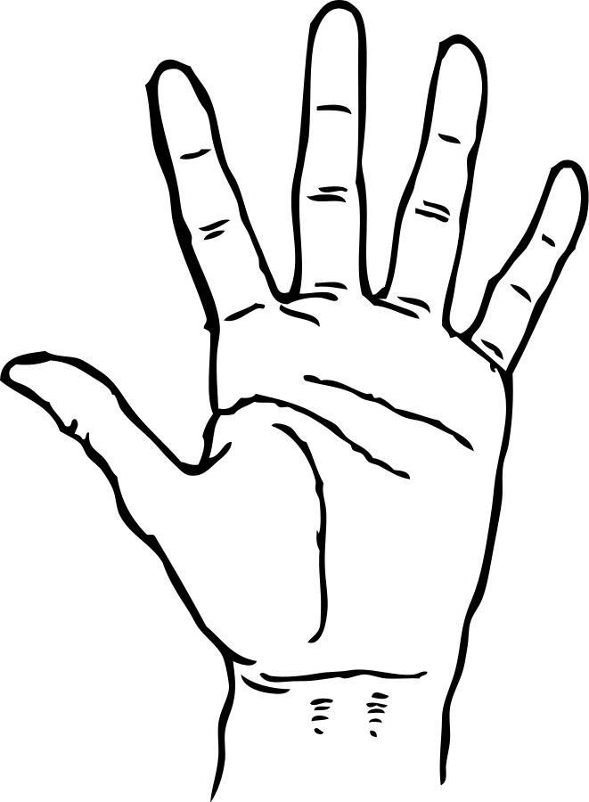  Tactile Learner | Auditory Learner
Teacher Lesson  Mini Checkpoint | FQ: What is Multiplication?  Each Orange has 8 Slices  Complete the Each Orange has 8 Slices Activity and watch the video to learn how mathematicians talk about multiplication! | FQ: What is Multiplication?  Unifix Cube Multiplication Activity  Directions: Use the Unifix cube Multiplication Directions and unifix cubes to learn the parts of a multiplication sentence!  **Challenge: Create 2 more examples in your notebook. Label the factors and products in your math notebook. ** | FQ: What is Multiplication?  Multiplication Cookies!  While you watch the video create the examples in your notebook! Draw all the pictures and label! | Step  1
Teacher Lesson  Mini Checkpoint | FQ: How do I use addition and groups to represent multiplication?  Become the Teacher!  Follow along with the smart doc to learn how to use groups and addition to represent multiplication! Use chips to help you! | FQ: How do I use addition and groups to represent multiplication?  Amanda Bean’s Amazing Dream  Watch the Amanda Bean’s Amazing Dream Video! Use chips to help you complete the activity! Remember: Think of Multiplication as GROUPS! | FQ: How do I use addition and groups to represent multiplication?  Brain Pop- Repeated Addition  Watch the video and complete the examples in your math notebook! | Step  2
Teacher Lesson  Mini Checkpoint | FQ: What is division and how do we understand division as sharing?  Division as SHARING:  While you watch the video, copy the problems and label each part of the division problem! | FQ: What is division and how do we understand division as sharing?  Skittle Activity  Sign up to meet with your teacher to learn how we can share skittles equally with our friends! Yes! Division is sharing!  ___ skittles,  shared into ___ groups  = ___ in each group | FQ: What is division and how do we understand division as sharing?  Division Mania Video  Watch how we use division to share equally! Draw the problems in your notebook with each equation! | Step  3

Fluency PRACTICE! | STEP 1  Time:_________  # Attempted:_______  # Correct: _________ | STEP 2  Time:_________  # Attempted:_______  # Correct: _________ | STEP 3  Time:_________  # Attempted:_______  # Correct: _________

Multiplication 3.OA.1 / 3.OA.2 Name:_______________
Directions: Complete two choices from each step on your pathway board! You may not move onto the next step, until your teacher has checked your completed activities. Have fun and work hard!

Do I need a Teacher Directed Lesson? | Visual Learner | Tactile Learner | Auditory Learner
Teacher Lesson  Mastery in Step 1 Shown | FQ: How are multiplication and division related?  Watch the Video to learn how multiplication and division are related! Record the examples in your notebook! | FQ: How are multiplication and division related?  FACT FAMILY MANIA  Use the chips to help you solve the multiplication and division problems in Fact Family Mania! Learn how we use multiplication and division together!  *Answer to focus question:________________________________________ | FQ: How are multiplication and division related?  Fact Families  Listen and watch the video to see how we use multiplication and division together! Record the examples in your math notebook! | Step  4
Teacher Lesson  Mastery in Step 2 Shown | FQ: How do I represent multiplication and division with arrays?  See the Teacher for the Smart Board Lesson!  Array Picture Cards- Use Recording Sheet  Choose an array picture card. Write a multiplication word problem to match your card. Write a multiplication number sentence to match your card. Write a division word problem to match your card. Write a division number sentence to match your card. | FQ: How do I represent multiplication and division with arrays?  Build Arrays- Directions and Materials Needed  Roll the die twice. Draw each array in your notebook and record the multiplication and division sentence in your notebook!  Onion Farm Task  Complete the Onion Farm Task! The farmer needs your help to create rows of onions! Use the unifix cubes to help you! | FQ: How do I represent multiplication and division with arrays?  Watch the Video to learn how we use arrays to represent multiplication!  FISHY ARRAY GAME! Play the array fishy game! Become a fish and solve the multiplication problems! | Step  5
Teacher Lesson  Mastery in Step 3 Shown | FQ: How do I create arrays with a given product?  CHIP GAME  Take 24 chips. How many ways can you arrange the 24 chips into equal rows and columns? Draw the arrays in your math notebook and label! | FQ: How do I create arrays with a given product?  Equal Marching Band Rows  Directions and materials needed! Use graph paper to show the arrays! Color in each array and label! Cut and glue arrays onto construction paper! | FQ: How do I create arrays with a given product?  See the Smart Board Lesson with the Teacher!  EDUCREATION VIDEO!  Create an Educreation showing how you can create arrays with the product a 32! Listen to your video and share with a partner! | Step  6

Fluency PRACTICE! | STEP 1  Time:_________  # Attempted:_______  # Correct: _________ | STEP 2  Time:_________  # Attempted:_______  # Correct: _________ | STEP 3  Time:_________  # Attempted:_______  # Correct: _________

